Know Your User persona template
Margaret07.2015Design Tools, Legal Product Design, User Research ToolsLeave a Comment
This is a template I use with my design process to capture small Personas of my target users. Forcing myself to write down who will be using my design helps me to focus on adding features & functions that will engage them, and give them value.
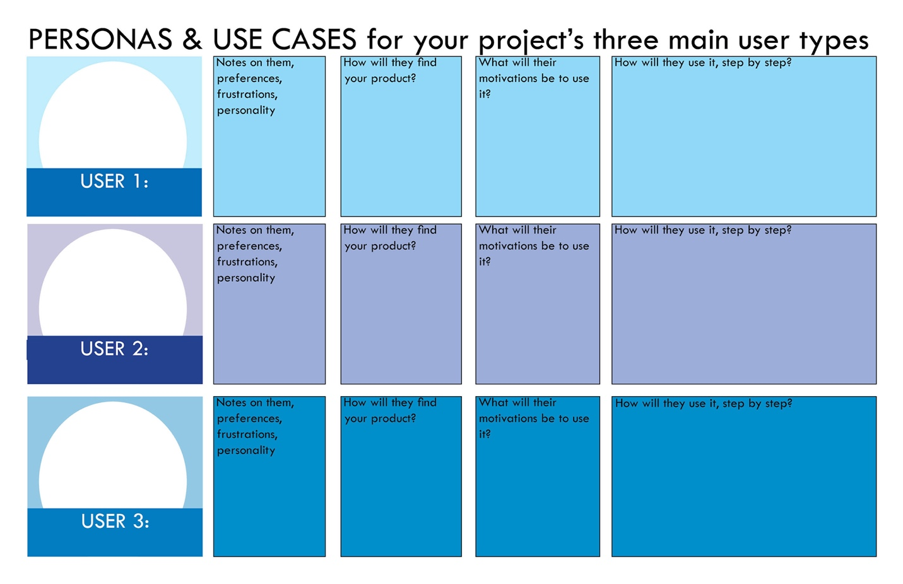I recommend having a hierarchy of users — with some taking precedence over others, to help you make good design decisions and not necessarily try to please all of them with each choice you make.

Once you fill it out, you can keep it posted on your wall to be your lodestar as you’re developing out the project.

Here is a black & white version too, if that suits your printing needs better.

